1. **Agenda**:
   1. Text

      Description automatically generated
2. **Collection Runner** is included in the Postman and is the first step towards test automation.
3. It is a useful way to run the entire collection or a subset of it by selecting a specific folder without any external tool.
4. The requests will be executed in the order in which they are specified in the collection if no other workflow instructions are specified, for example, **setNextRequest**() is not set.
5. 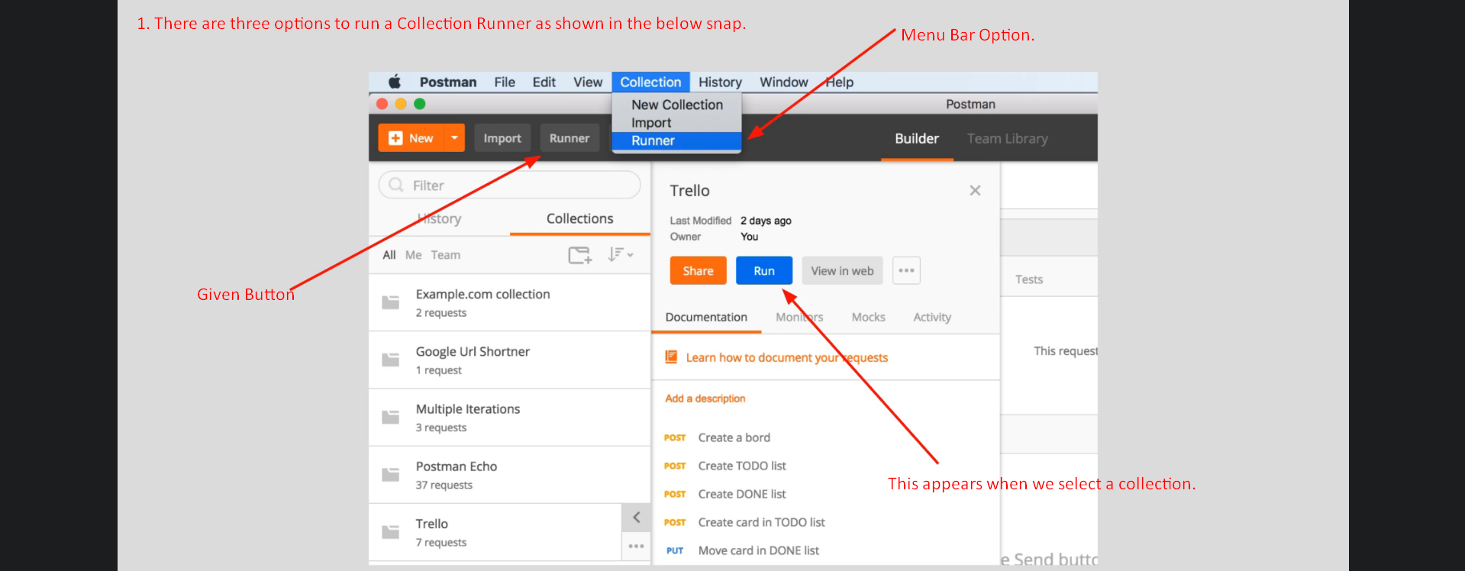
6. When you click on runner (any option), **Collection Runner** will pop up.
   1. **Selecting a collection**: You can select a collection or a subfolder inside a collection to run.
   2. **Iteration**: Later on, we will see how to use **iteration** **option** to generate data dynamically.
   3. **Delay:** If you’re dealing with an API which is a bit not so responsive, you can include delay.
   4. **Logging:**
      1. You have the possibility of logging responses and requestions.  
         Graphical user interface, application

         Description automatically generated  
         So, we will see it when we will run the collection runner.
   5. **Data**:
      1. You can select a CSV or JSON Data file that the collection runner will be using for the requests in it.